|  |  |  |  |  |  |
| --- | --- | --- | --- | --- | --- |
| Date | 13-Dec-22 | | | Tester Name | Andrew McLaughlin |
| Environment | Penfax - Test | | | Login used |  |
| Operating System | Windows | Version: | Update: | | |
| Software Used | Select Software | Version: | Update: | | |
| Select Software | Version: | Update: | | |
| Release version | 22.4.1 | | | | |
| Title | V5 1.08 Case Management Overview | | | | |
| Test Type | Regression | | | | |
| Test Scenario | V5 1.08 Case Management Overview | | | | |
|  |  | | | | |
| Expected Results |  | | | | |
| Pass/Fail | Pass | | | JIRA# | N/A |

Describe your steps with screenshots:

Create a Case:

Go to a member’s file and open the Cases section and hit Add Case

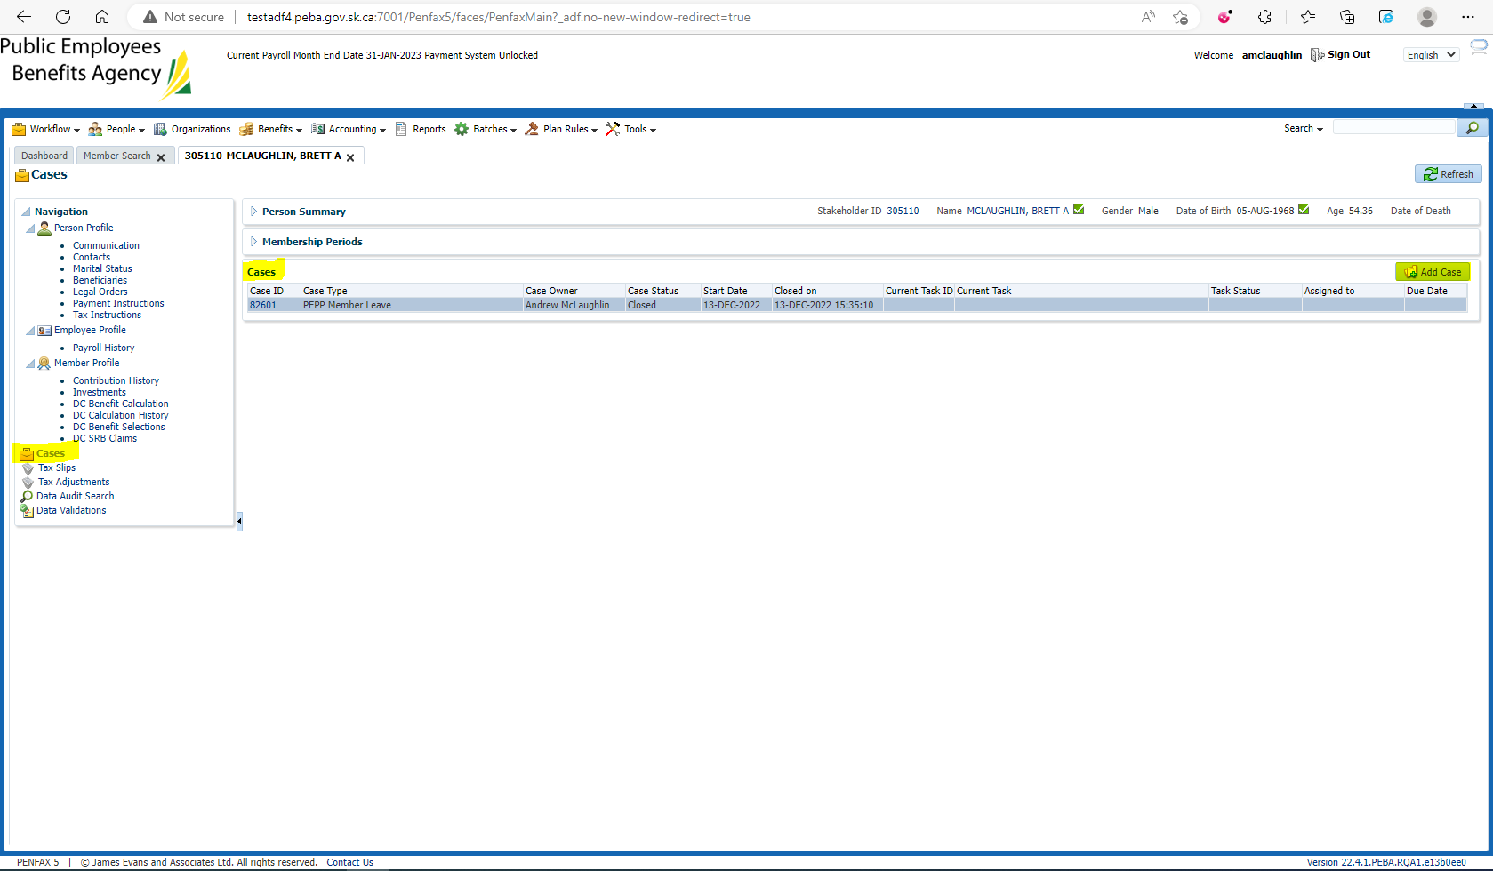

Select a Case Type and hit Save

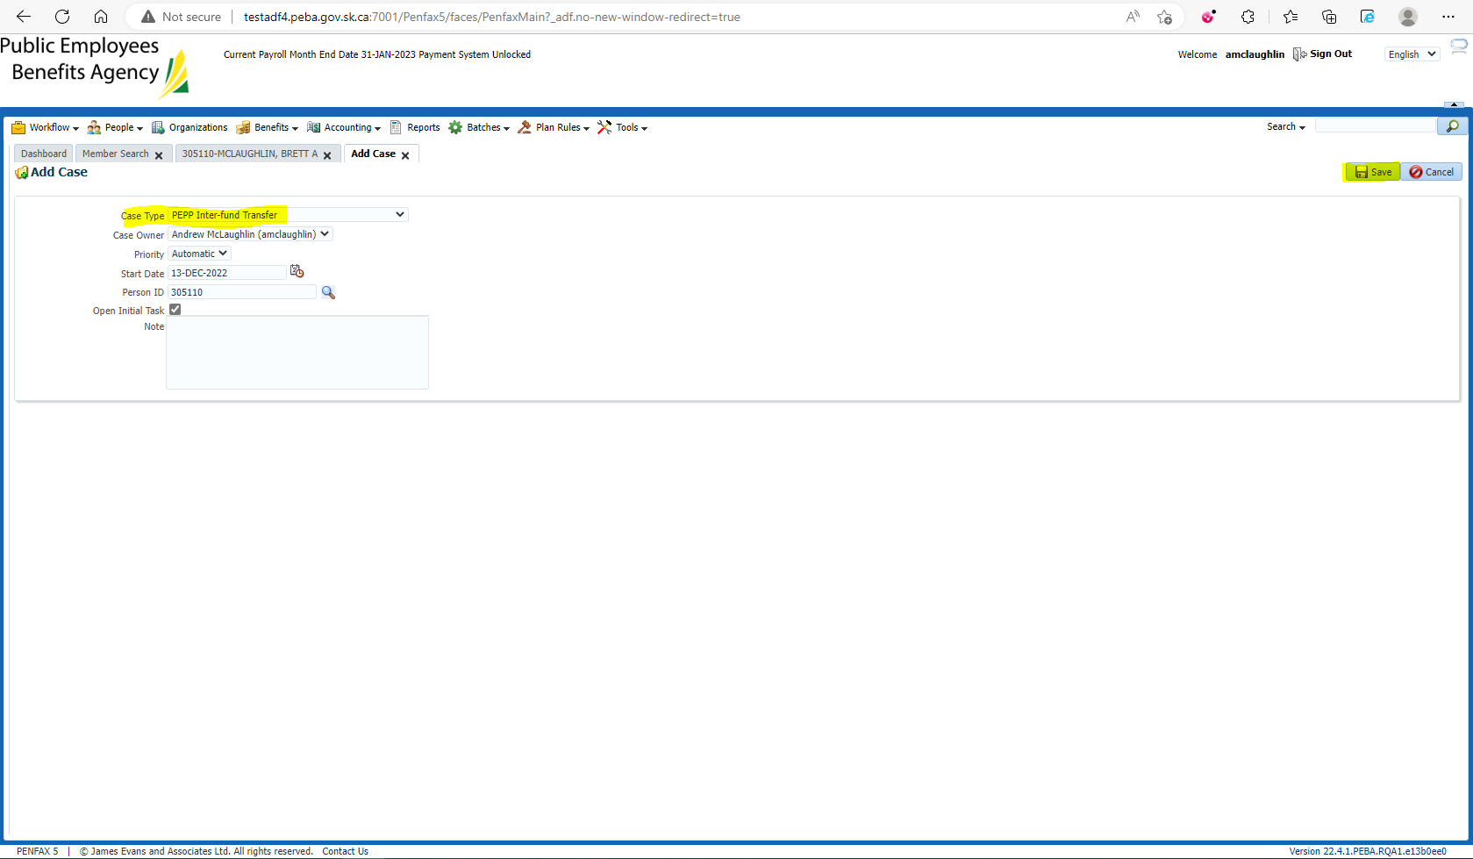

Navigate to Dashboard tab. Verify you are able to see the case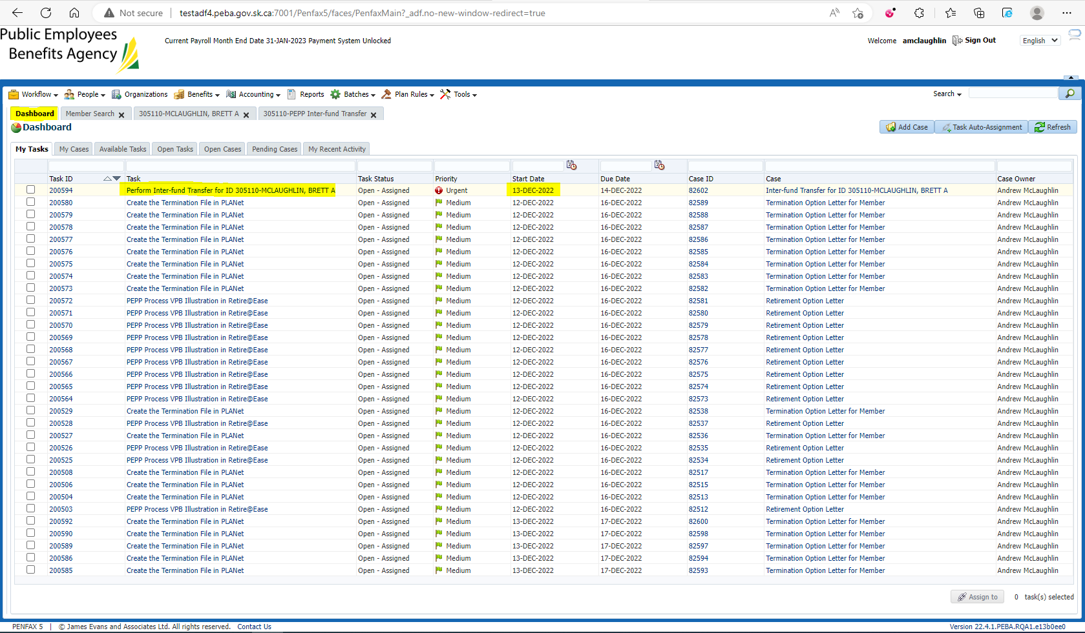

Again under the My Cases tab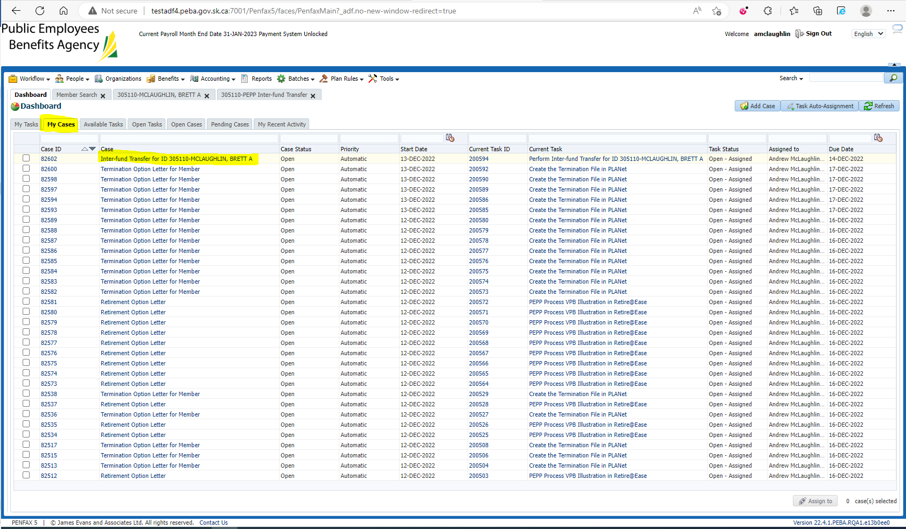

Click on Open Tasks tab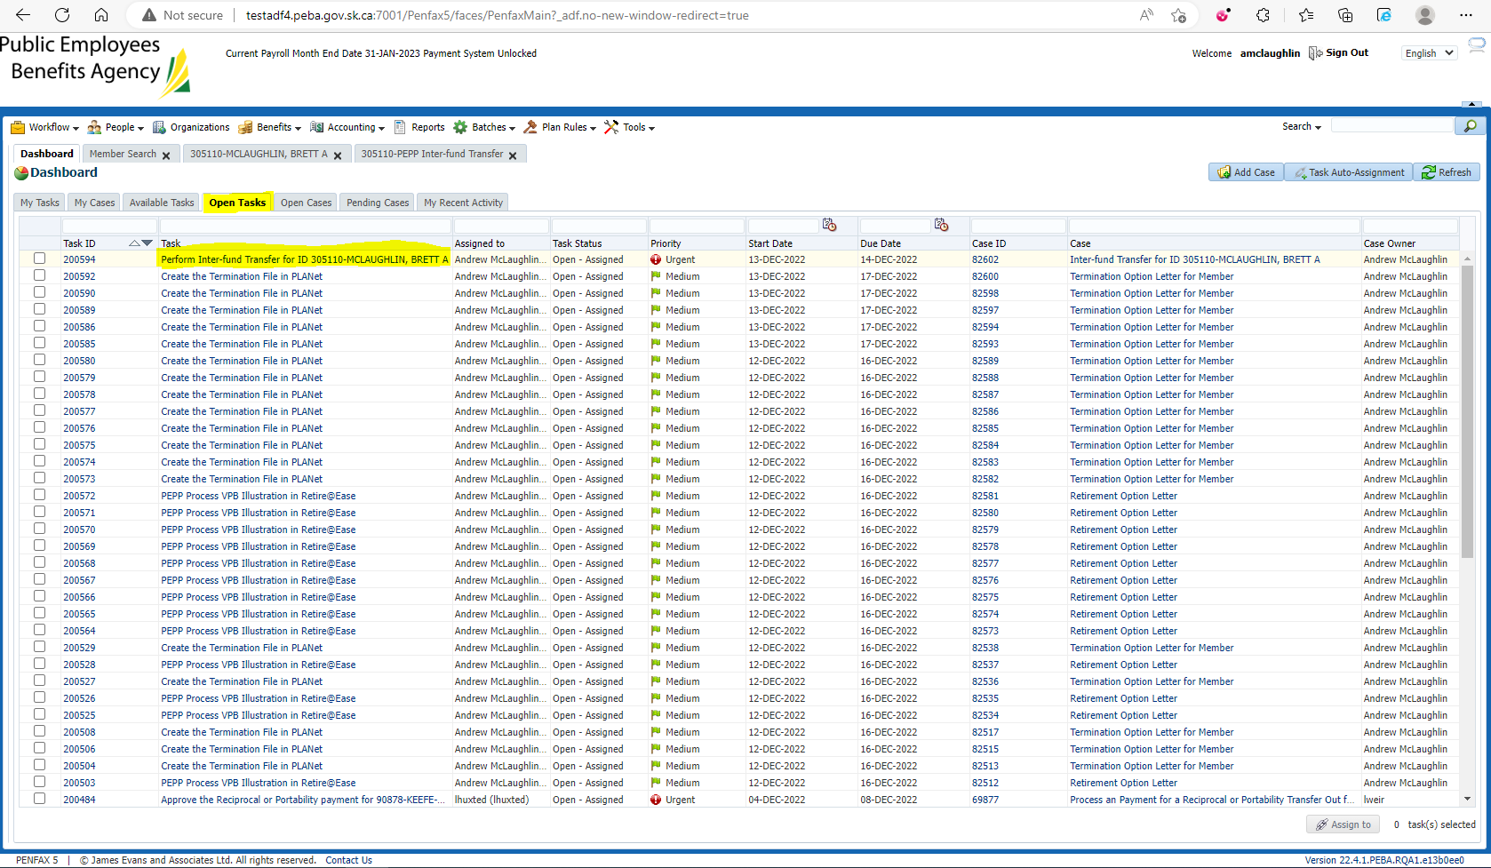

Click on Open Cases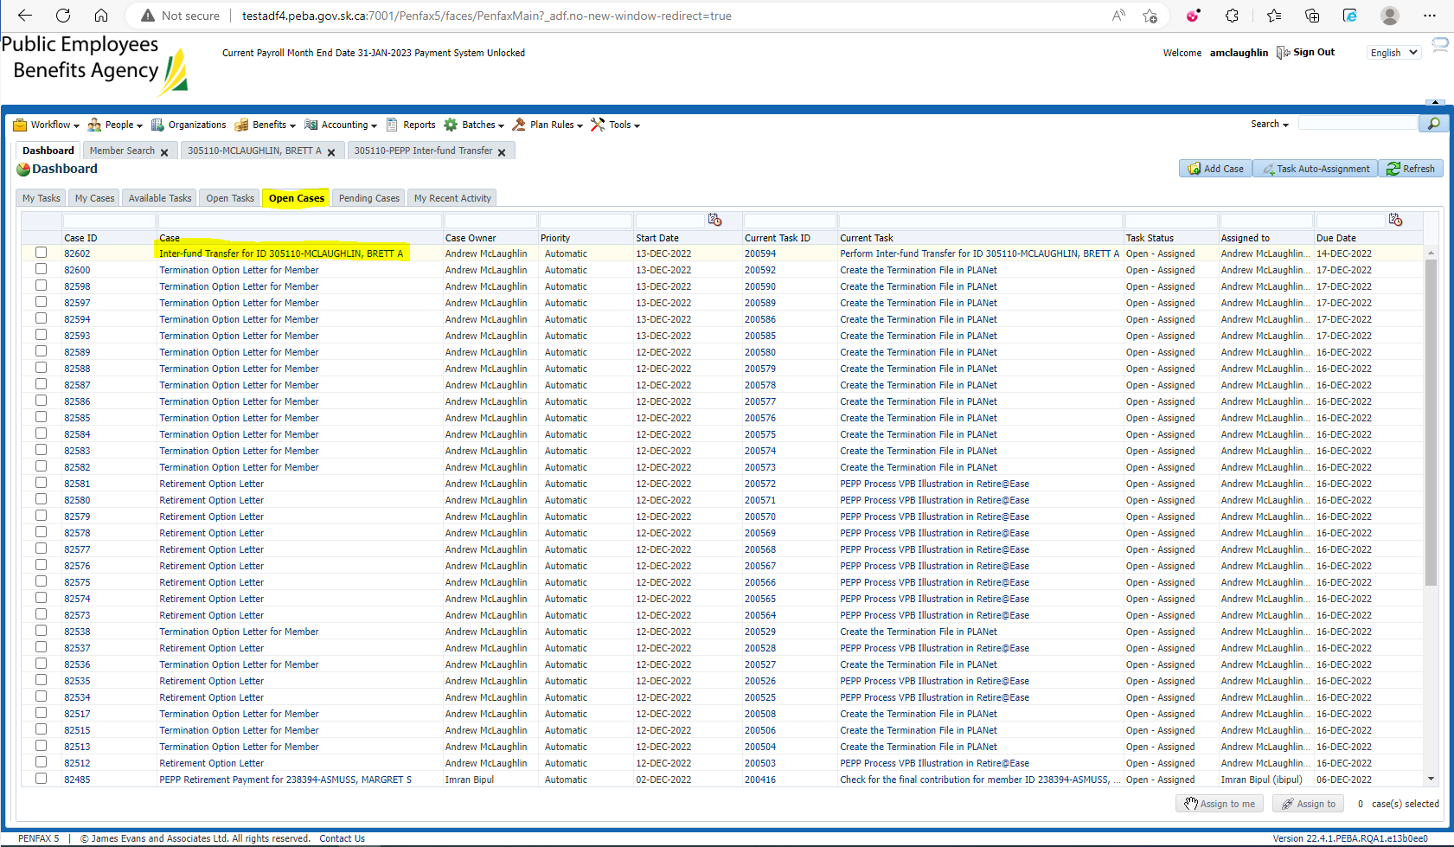

Click on Pending Cases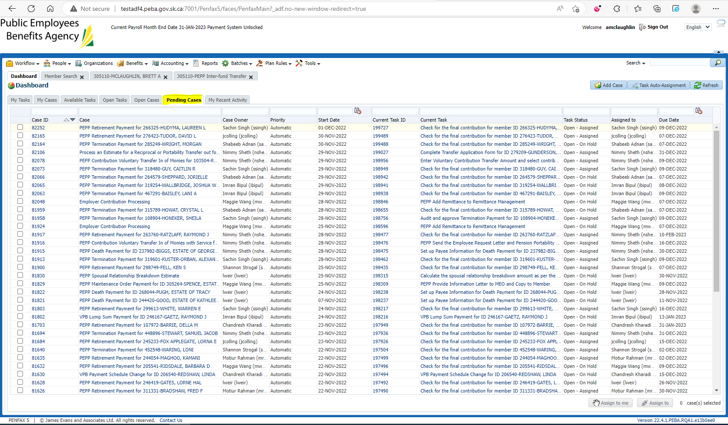

Click on My Recent Activity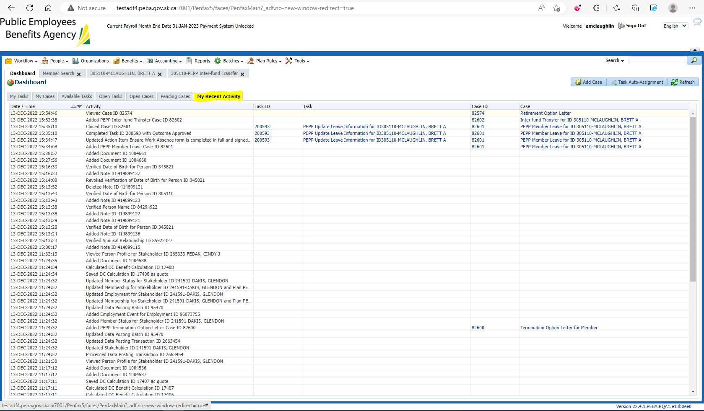

To complete the case. Click on the Pencil icon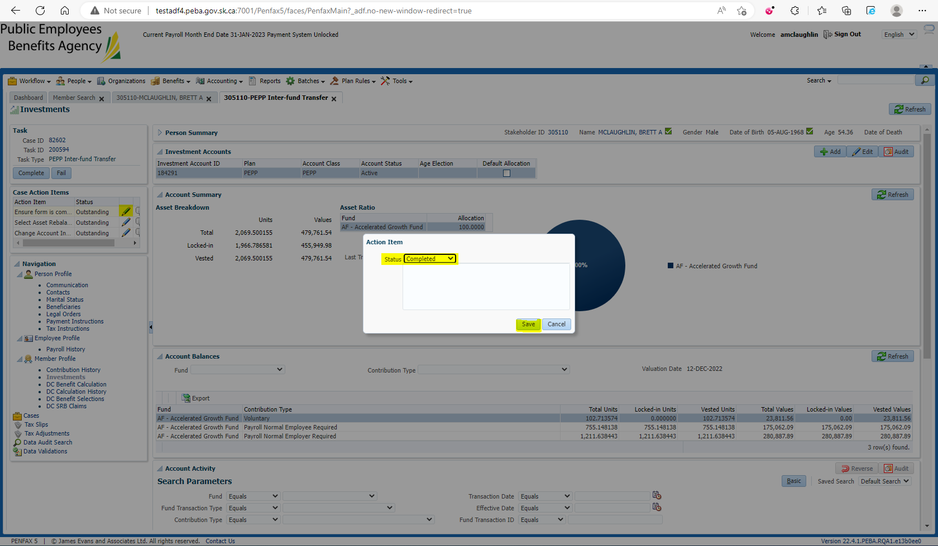

One all action items are complete, complete the Task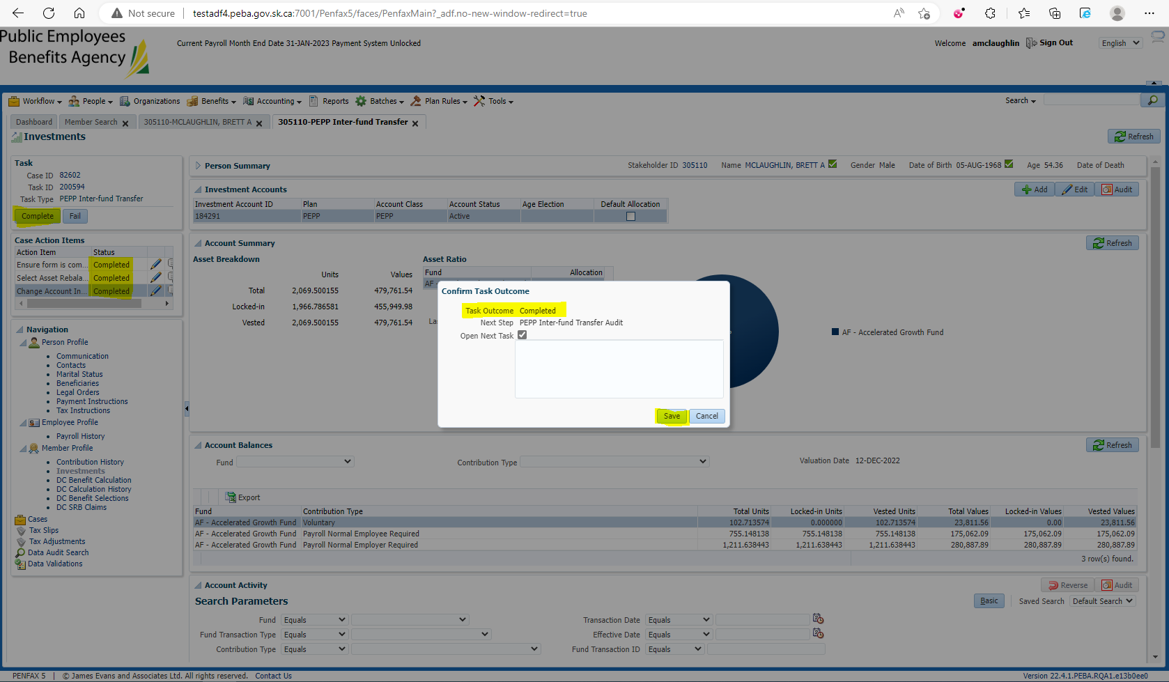

After completion. Case is not present in My Tasks